Name : Vedant Agre
Class : CSDS-A
Roll no: 09

ASSIGNMENT 2

Q1 Create a table of student with name, marks, email id, address, attendance. Format the header role with the bold text and give alignment as centre also add background colour.
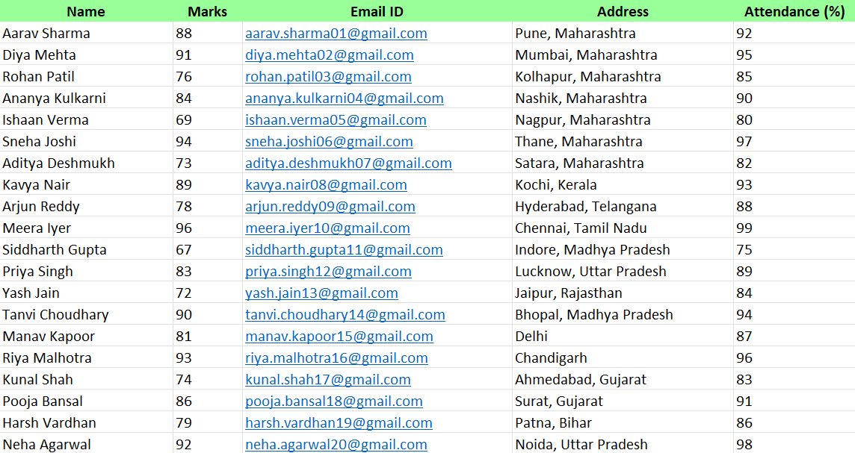

Q2 Change the number format of marks to number with 2 decimal places.
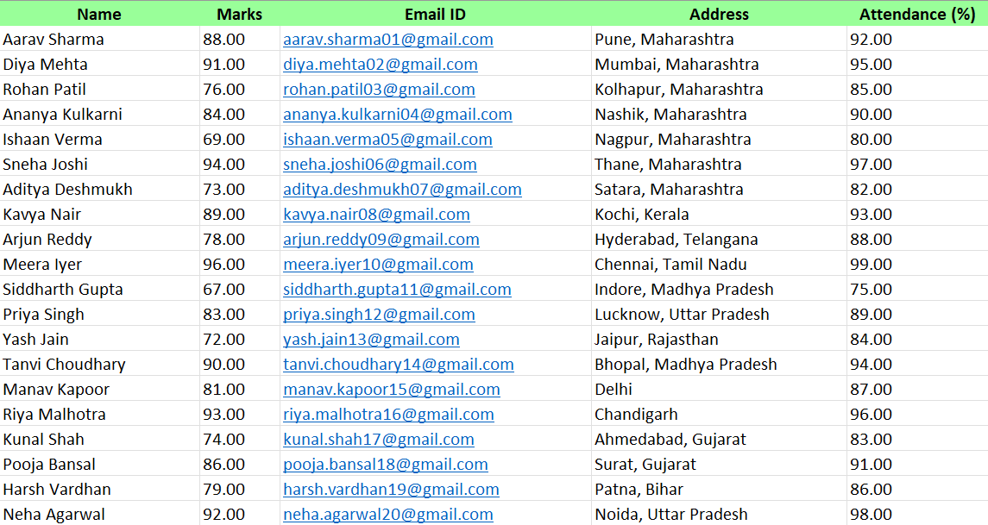
Q3 Apply border to entire data table.
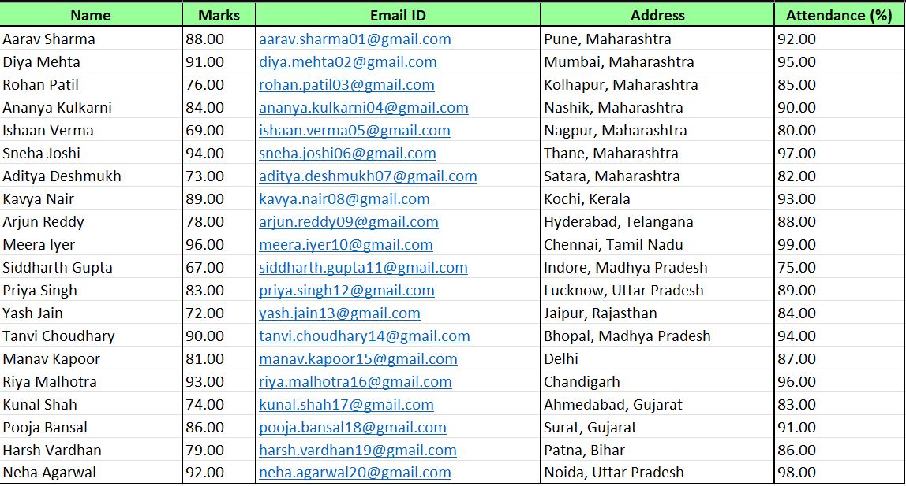
Q4 Use wraps up text to display long text within a cell properly.
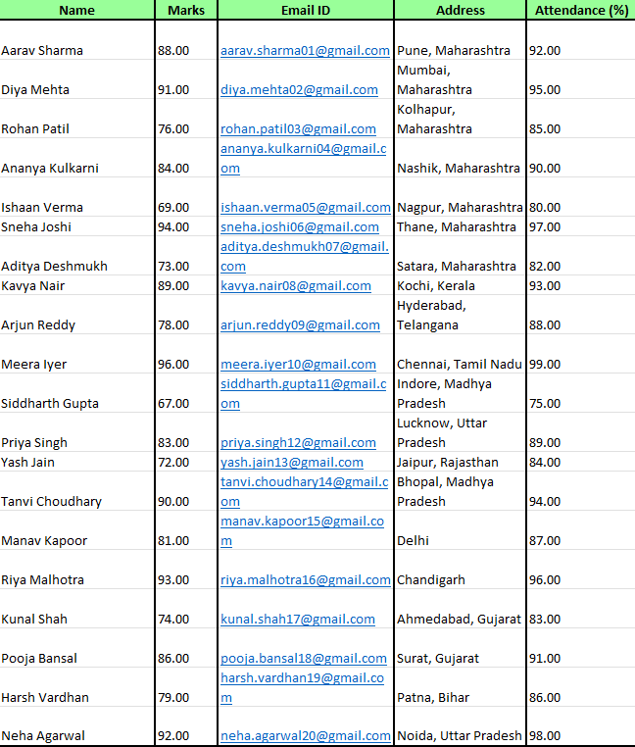

Q5 Merge cells A1 to D1 and add title student performance report.
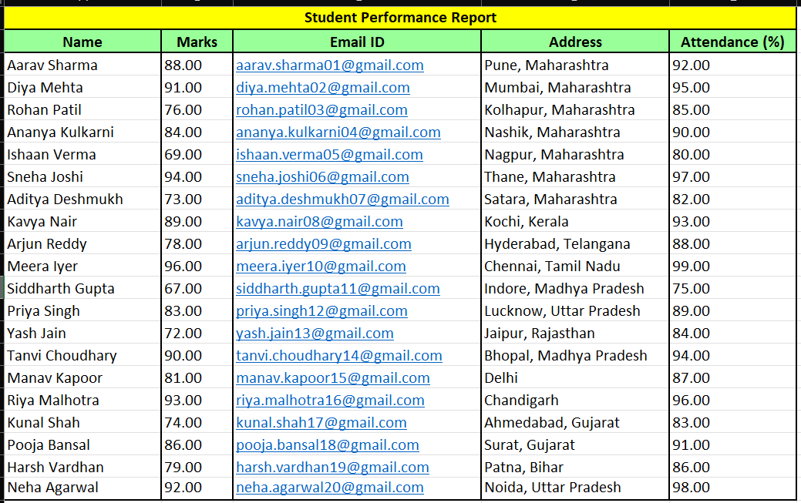
Q6 Highlight marks greater than 80 using conditional formatting.
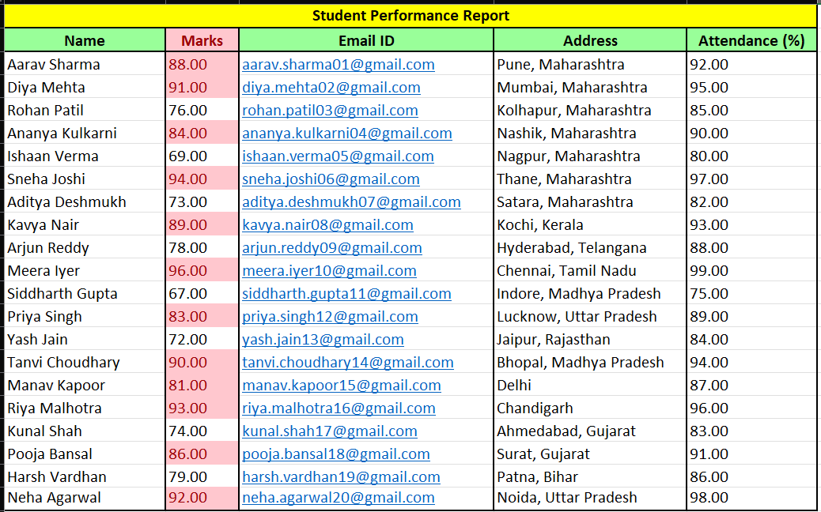

Q7 Highlight marks less than 40 using red color.
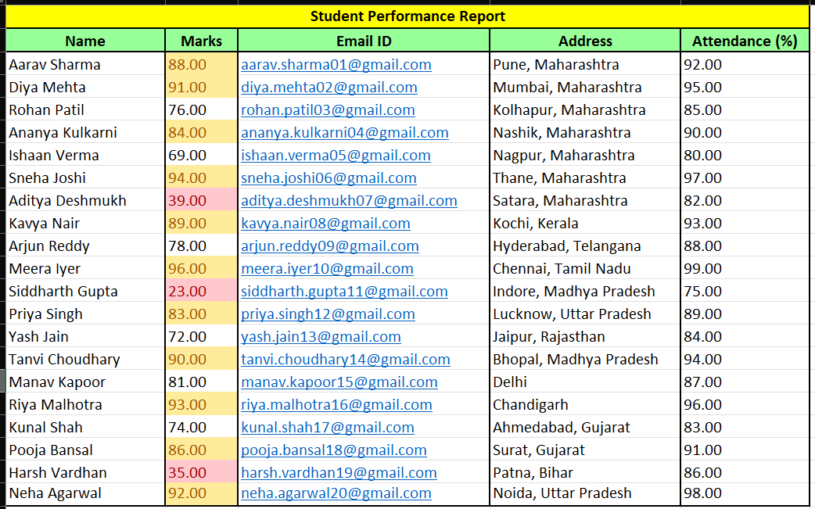
Q8 Apply above average conditional formatting to marks.
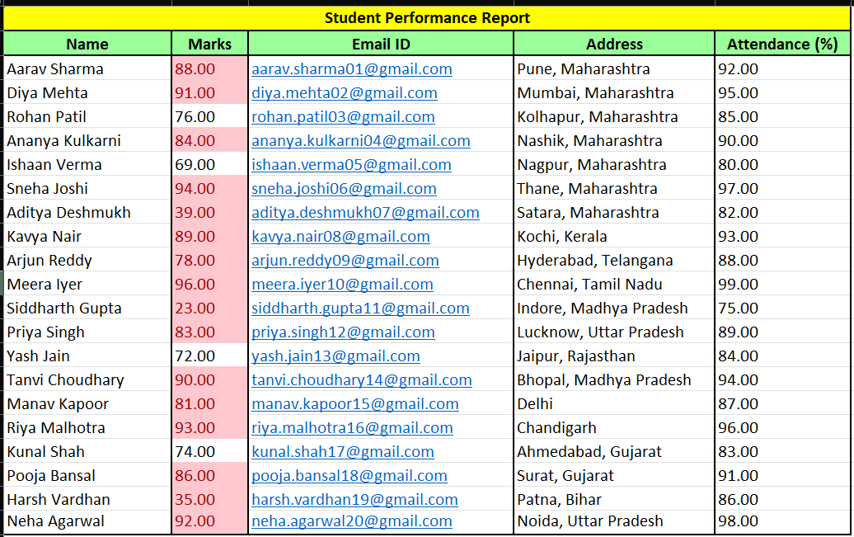

Q9 Apply data bars to visualize marks.
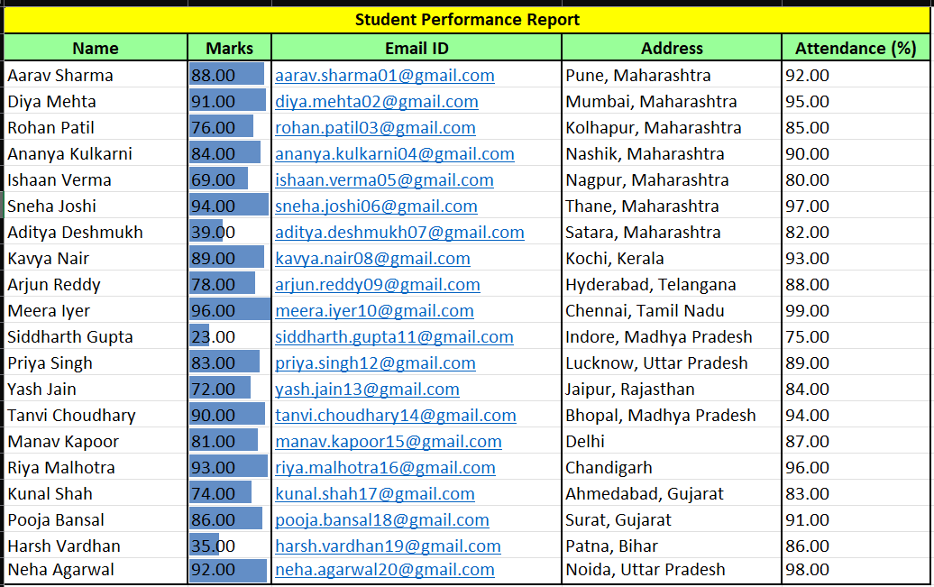
Q10 Apply colour scale to marks and show lowest to highest value.
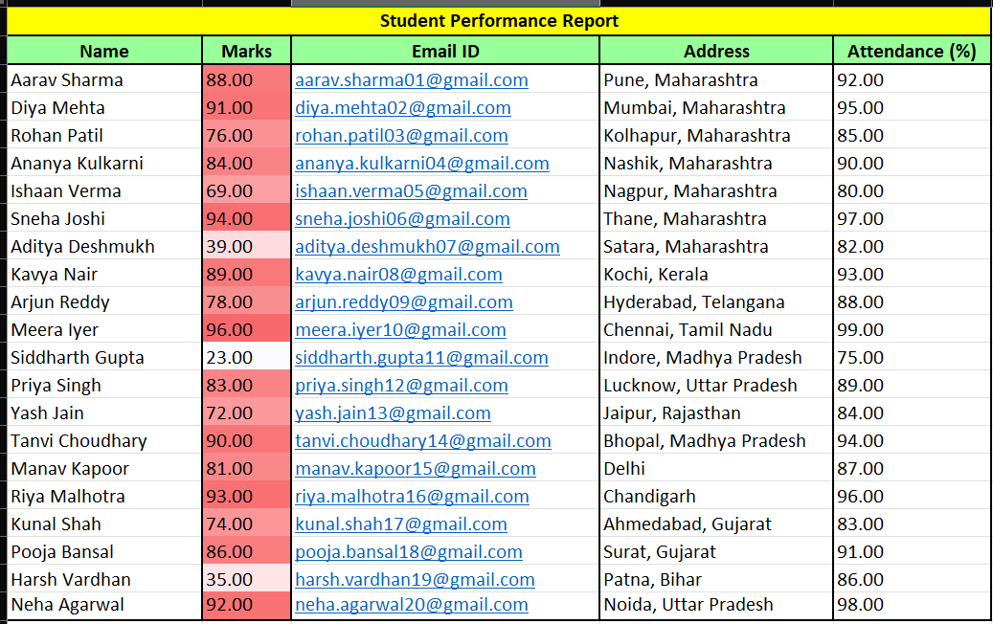

Q11 Use icon sets to indicate performance level.
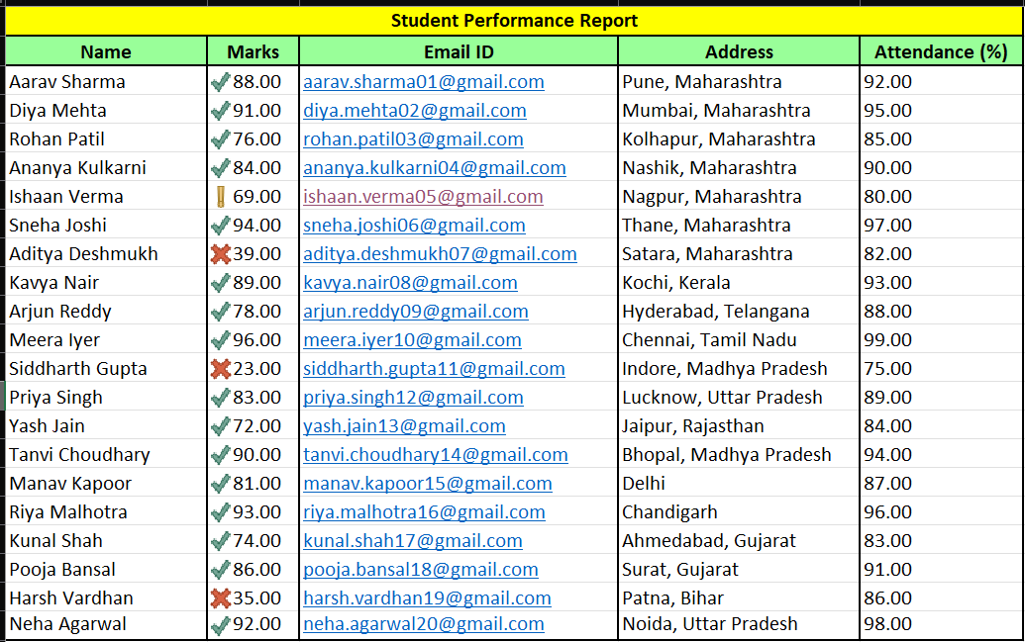
Q12 Remove duplicate records from the Data Set
